Frank Lyles

EA 30

December 13, 2016

Climate Change in Pomona, California

Southern California’s weather has been consistently in the national headlines in recent years, as the state attempts to cope with what is likely to be the worst drought in at least the last 1200 years.[1] Simultaneously, the scientific consensus around the urgent threat posed by Global Climate Change makes it tempting to blame the former on the latter. California has always had periodic droughts however, and no single weather event--even a multi-year drought--is sufficient evidence of a change in climate by itself. Thus, there is a disconnect between the real experiences of people living in an increasingly brown Golden State and the more abstract forecasts and models of climate scientists. Is California’s weather already changing, and either way, what does the future hold?

One way to attempt to answer that question is to examine the long term weather data of a particular place. For this report, I have chosen the the temperature and precipitation records from 1893-2016 as measured at the Pomona Fairplex,[2] which is located just over 4 miles from Pomona College. The data show a slight increase in monthly maximum temperatures (**see below**), but the change is very slight and not quite statistically significant (p-value: 0.08617). However, perhaps just examining monthly maximum temperatures is not the best way to detect a change in Pomona, California’s long term climate. If we simplify the data to instead just show the mean value for daily maximum temperature over a given month, in this case December, a steeper trend appears (**following page**):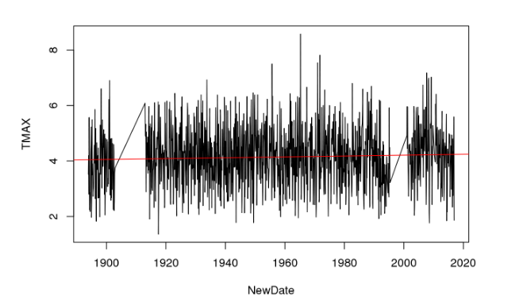

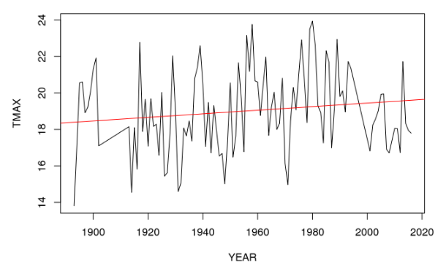

With a slope of 0.009796, or 0.9℃ per 100 years, it would appear that December maximum temperatures are indeed getting warmer, albeit by less that a degree celsius per century. Unfortunately, this regression’s p-value is 0.1303, so the increase does not meet the standards of statistical significance. And with an Adjusted R-squared of 0.01235, one cannot claim that the passage of time is a very large explanatory variable.

Performing that same process on each year’s minimum temperature measurement for December finally gets a highly statistically significant result (p-value: 4.043e-10) (**See figure on following page**). The graph shows temperature still varying greatly year to year, but over time rising by a slope of 0.03291, or 3.2℃ per 100 years. This means that, on average, one could expect the coldest day in a 21st century December to be over 3℃ degrees warmer than the coldest day of December 100 years ago. The regression has an r-squared of 0.312, meaning that nearly one-third of the variation in temperature data can be explained simply with the passage of time. This type of regression cannot prove causality, so the observed rise in temperatures may be as a result of climate change, some cause such as urban heat island effect, or something else; it is impossible to conclusively say with this statistical method, but this regression does strongly indicate that cold winter temperatures are less common in Pomona, California now than they once were.

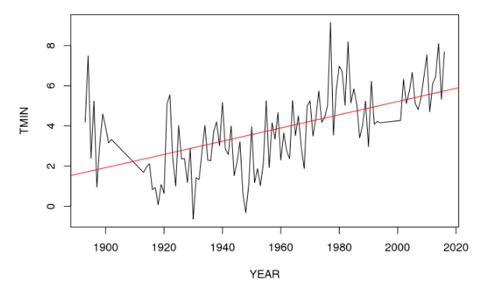

In addition to concerns about rising temperatures, the recent drought in California has highlighted how vulnerable the state is to changes in precipitation. Many people are eager to know: over time, has the state gotten significantly drier? A regression of total yearly precipitation was graphed in green (**see below**) and does indeed show a slight decline over time, but it is not statistically significant (p-value: 0.1966). The graph also shows the mean yearly precipitation for the full time period, in blue, and the departure from the mean, in red. While the overall trend was not statistically significant, it is interesting to note that the last several years have been farther below the long-term mean than any other time in the full sample; in other words, even if is not yet enough to create a statistically significant trend, the recent drought is unprecedented in the 123-year historical record.

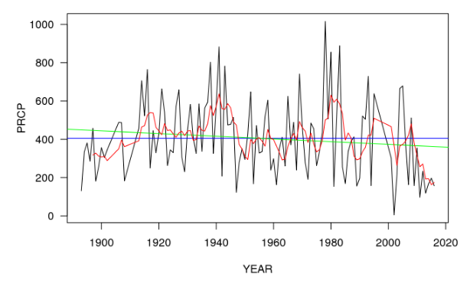

The data as a whole are suggestive and concerning, but not conclusively dire. Southern California may be getting warmer and drier, but more time may be needed for the long term temperature and precipitation records of Pomona Fairplex to show that trend. In the meantime, people can either wait and see if those climate change impacts do eventually begin to unambiguously manifest themselves, or they can try to foresee and proactively adapt to those impacts by studying the forecasting models produced by climate scientists.

Climate projections based on low emission trajectories predict “temperature increases will likely exceed 3°F” by the year 2100 compared to a 1961-1990 baseline; high emissions trajectories could produce warming in excess of 7°F.[3] There seems to be pretty tight agreement among the scientific literature that California will become warmer, with the debate being mostly about timing and magnitude at this point. The effect that climate change may have on precipitation is more difficult to constrain. Berg and Hall (2015) analyzed the results of 34 global climate models and concluded that while “models disagree on the sign of projected changes in mean precipitation” for the state, “in most models the change is very small compared to historical and simulated levels of interannual variability.”[4] Extremely dry winters are not likely to increase in frequency until the latter half of the century, but extremely wet winters will “increase to around 2 times the historical frequency, which is statistically significant at the 95% level” by the year 2061. After 2061, all 34 models predict “extremely dry wet seasons [will be] roughly 1.5 to 2 times more common, and wet extremes generally triple in their historical frequency (statistically significant). Large increases in precipitation variability in most models account for the modest increases to dry extremes. Increases in the frequency of wet extremes can be ascribed to equal contributions from increased variability and increases to the mean [precipitation].”[5] Although Berg and Hall (2015) do not project an increase in the frequency of extremely dry winters until after 2060, this should not be misconstrued as an indication that the frequency of droughts will not increase before then. California’s 2011-16 drought is not the most severe of the last 1200 years because of low precipitation alone; low (but not anomalously low) precipitation has combined with record high temperatures to create the extreme moisture deficit.[6] Furthermore, The National Drought Mitigation Center notes that drought’s “impacts result from the interplay between the natural event (less precipitation than expected) and the demand people place on water supply, and human activities can exacerbate the impacts of drought. Because drought cannot be viewed solely as a physical phenomenon, it is usually defined both conceptually and operationally.”[7] For example, “Socioeconomic drought occurs when the demand for an economic good exceeds supply as a result of a weather-related shortfall in water supply,”[8] and this has certainly occurred even within the range of historical variability in Southern California precipitation.[9]

Given how urgent the threats of climate change are, especially on a global level, it could be tempting to take the weather data from the Pomona Fairplex and hold it up as proof that the climate of Southern California is already getting hotter and drier. That may be true, especially for winter cold extremes, but until the data can support such a statement conclusively and unambiguously, making such claims risks overstepping one’s bounds and creating an opportunity for climate skeptics to discredit and dispute sound science.

Therefore, the honest and accurate conclusion to draw from the Pomona Fairplex data is that we mostly haven’t yet the experienced the significantly warmer, drier conditions that can be expected in future. Decembers have much warmer minimum temperatures, but that was my only statistically significant result. For average conditions, the numbers just aren’t in yet. There is a danger inherent in that wait-and-see attitude, however; we’ll only be able to really quantify Southern California’s climate changes with certainty after those changes have already occurred, by which time it will be much harder to adapt to climate changes impacts. There may be a compelling case for acting now to mitigate and adapt to climate change, even without complete knowledge.

1. Griffin, D., and K. J. Anchukaitis (2014), How unusual is the 2012–2014 California drought?, Geophys. Res. Lett., 41, 9017–9023, doi:[10.1002/2014GL062433](http://dx.doi.org/10.1002/2014GL062433).
2. NOAA (National Oceanic and Atmospheric Administration). (December 16, 2004). Retrieved December 13, 2016, from https://www.ncdc.noaa.gov/cdo-web/orders?email=lylesfrank@gmail.com&id=856806
3. Cayan, D. (2009). Climate Change–What Should Southern California Prepare for? And the FUTURE of SOUTHERN CALIFORNIA, 10.
4. Berg, N., & Hall, A. (2015). Increased Interannual Precipitation Extremes over California under Climate Change. Journal of Climate, 28(16), 6324–6334. https://doi.org/10.1175/JCLI-

   D-14-00624.1
5. Berg & Hall (2015)
6. Mann, M. E., & Gleick, P. H. (2015). Climate Change and California drought in the 21st century: Fig. 1. Proceedings of the National Academy of Sciences, 112(13), 3858–3859. https://doi.org/10.1073/pnas.1503667112
7. National Drought Mitigation Center (2015) What is drought? Available at drought.unl.edu/DroughtBasics/WhatisDrought.aspx. Accessed March 4, 2015
8. Mann, M. E., & Gleick, P. H. (2015).
9. This lit review paragraph borrowed heavily from the wording used my thesis: Lyles (2016). Climate Change Adaptation for Southern California Groundwater Managers: A Case Study of the Six Basins Aquifer.